­

**1, buffer**

**Stack layout**

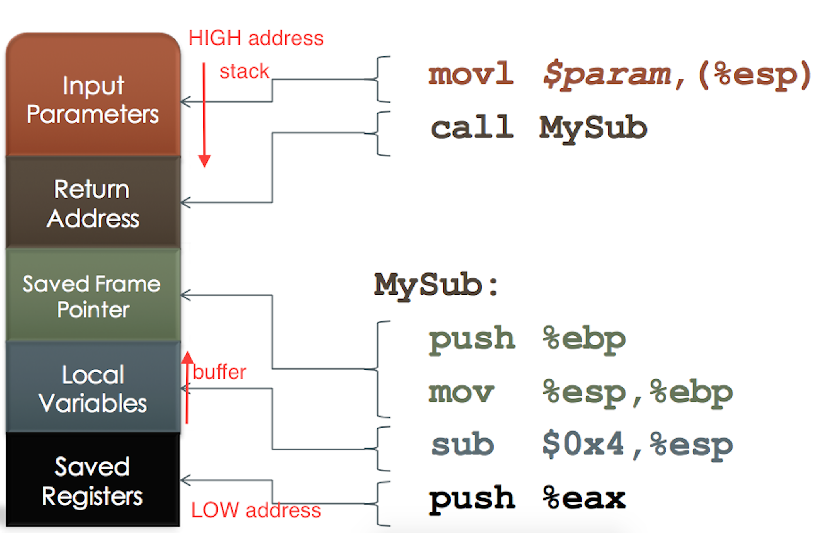

**Optimizing the Shellcode**

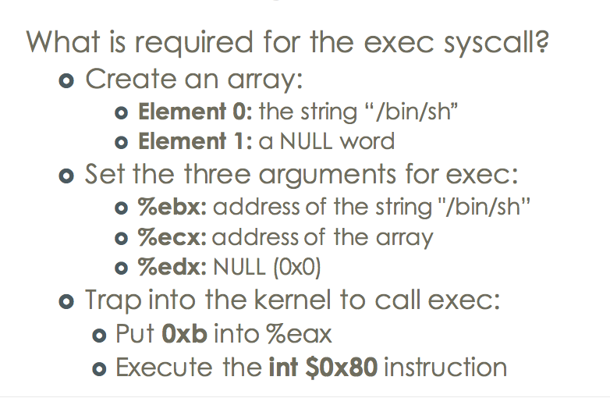

**Creating an exploit:**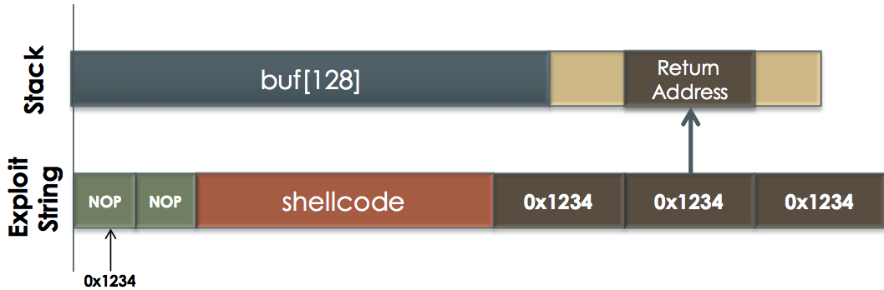

WhyNop1,we do not know the exact address of buf

2, CPU can skip thos instructions

3, better range to guess and trap into the system

**Same direction buffer and stack overflow:**

**Local variable stack layout**

**Snprintf operation**

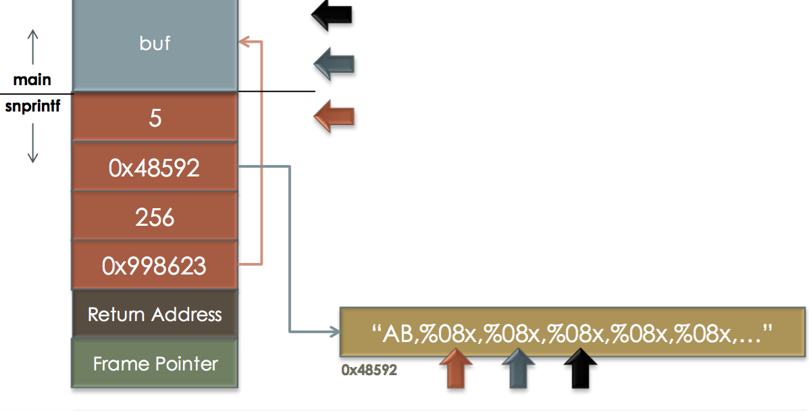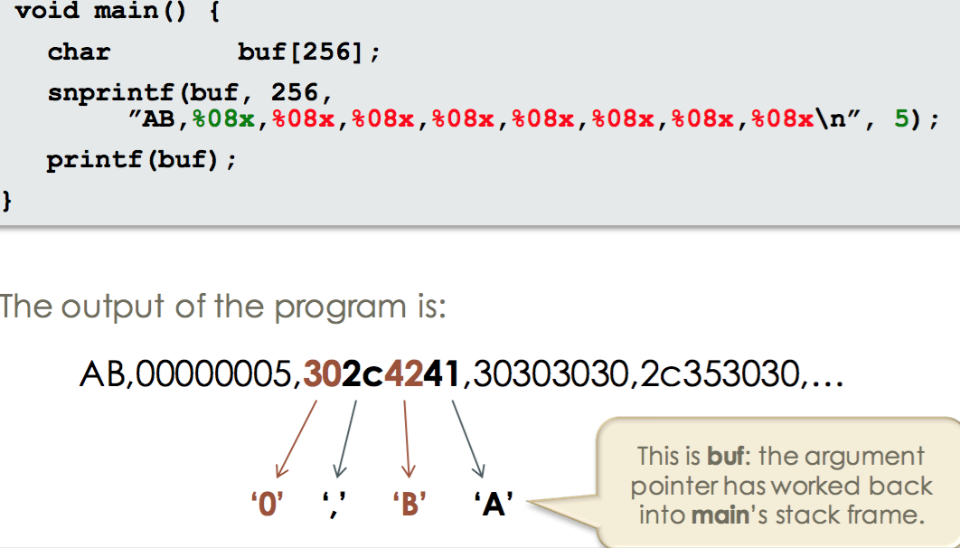

Format string attach

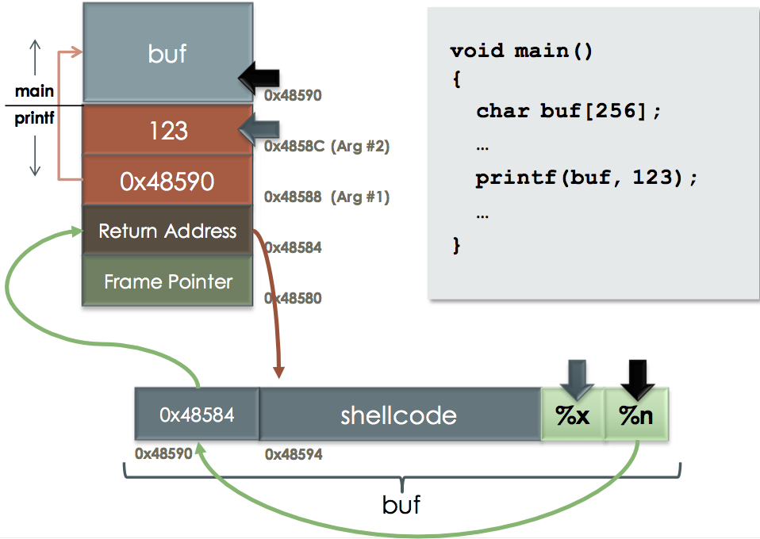

Overwritten the return address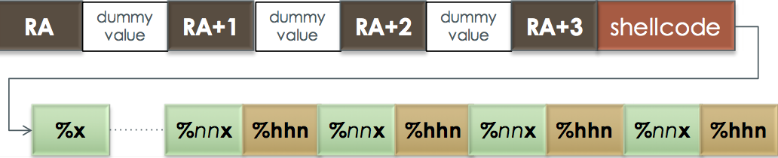

Double free

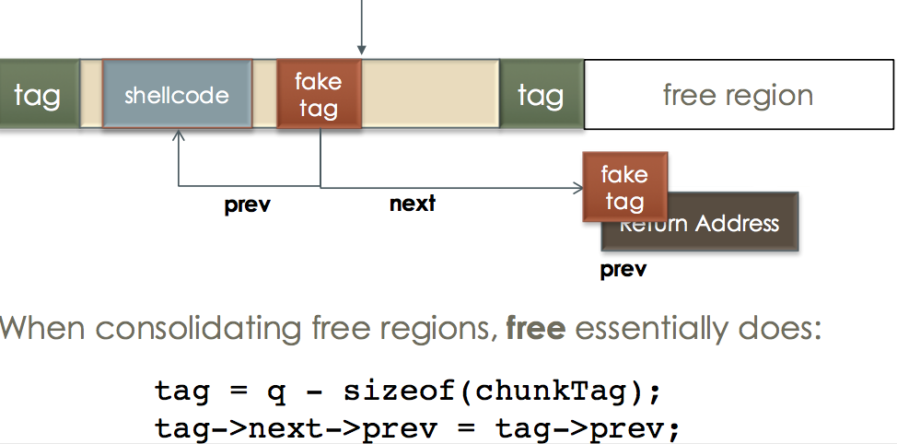

Funtion Pointers

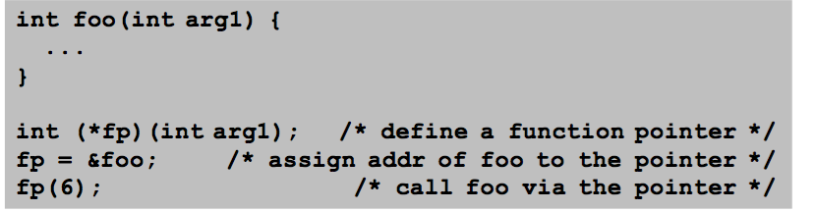

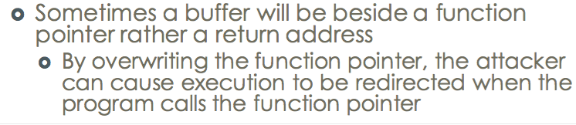

Defending Against Stack Smashing

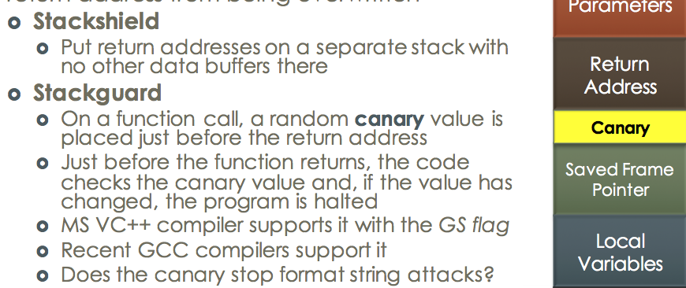

Return into libc

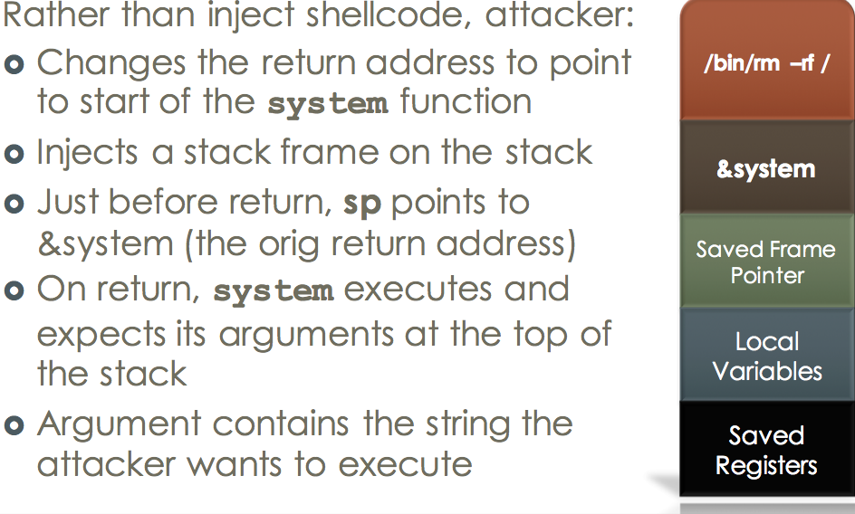

PLT/GOT

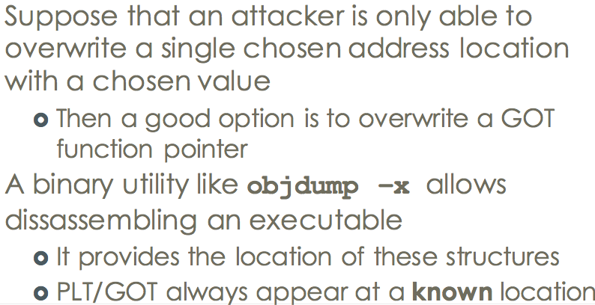

Dynamic link

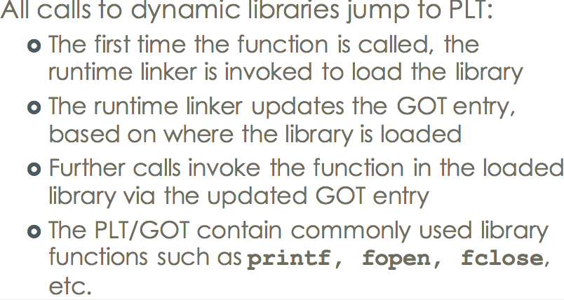

Argument overwrite

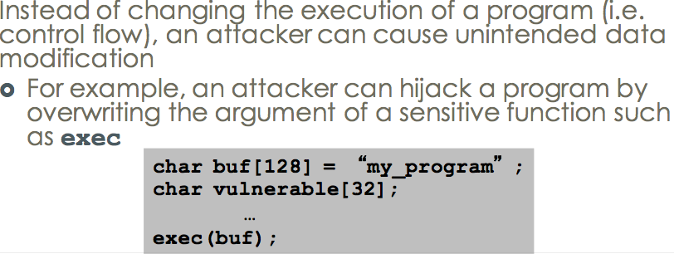

Address-Space Layout

Randomization (ASLR)

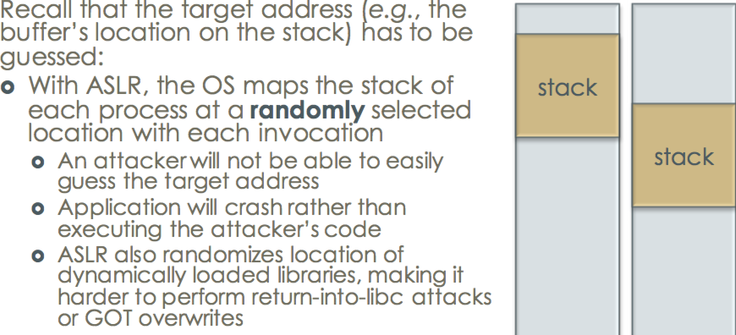

properties of Cryptography

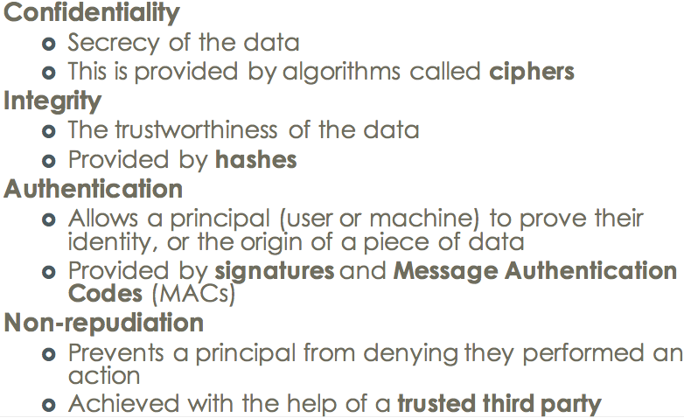

Cryptography kinds

1, Ciphertexts

2, Number of plaintext and ciphertext pair

3, pick a plaintext and get corresponding ciphertext or

vice-versa

Polyalphabetic Cipher

One-time pad problem

1, Key length = message length

- Key overhead of 100% is generally not acceptable

2, Each key can be used once (hence the name)

3, Cipher is malleable

4, Ciphertext-only:

- If used properly, impossible to break

5, Known-Plaintext ›

- Very weak ›

- just XOR CT with PT to reveal the key ›

- Only need one pair ›

- Of course, key is not supposed to repeat

6, Chosen-Ciphertext/Plaintext -> weak

Block Cipher

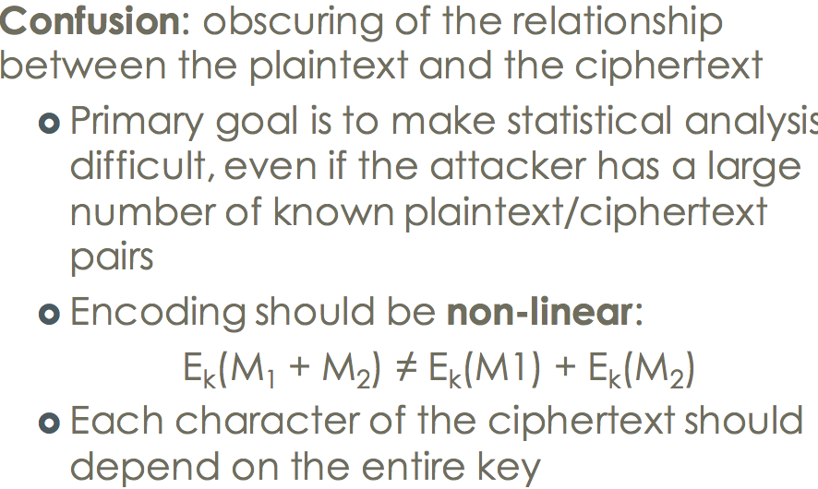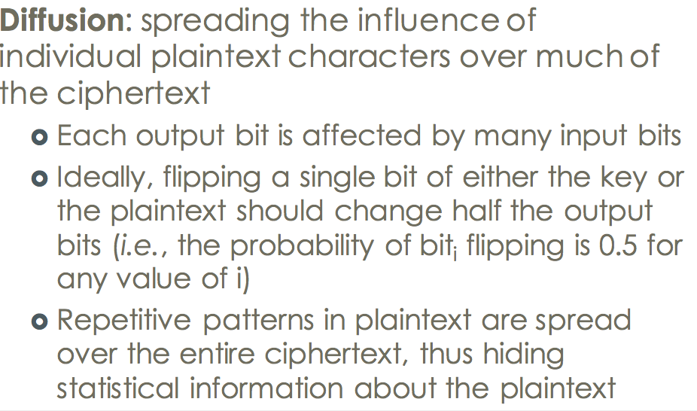

Block Cipher Design:

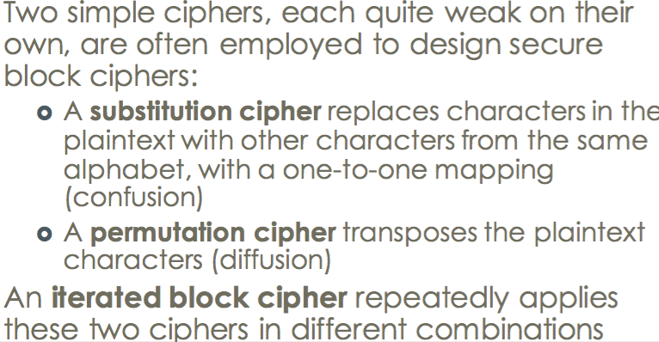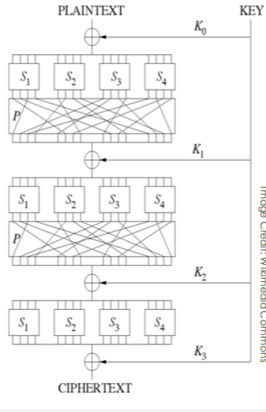

DES: Data Encryption Standard

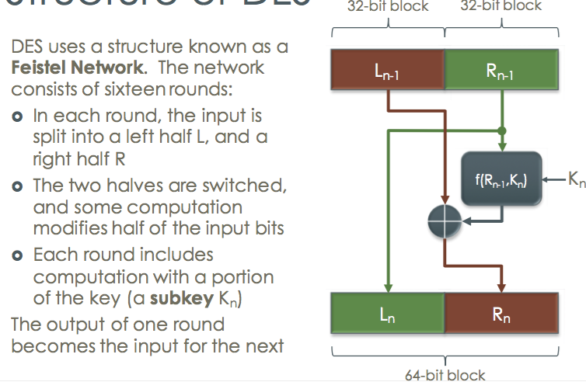

3DES

splitting a 168-bit key into three 56- bit parts

and running the algorithm three times

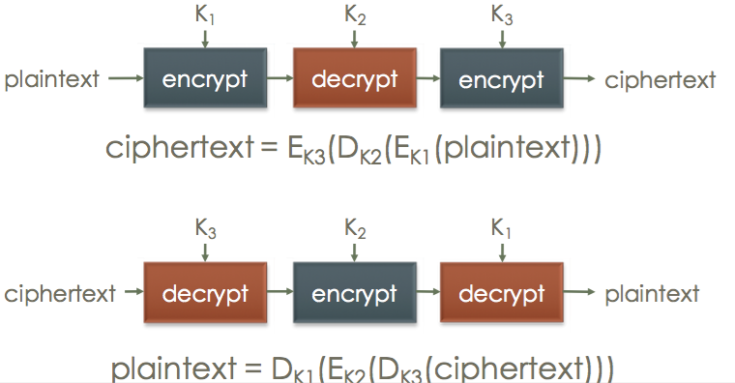

AES

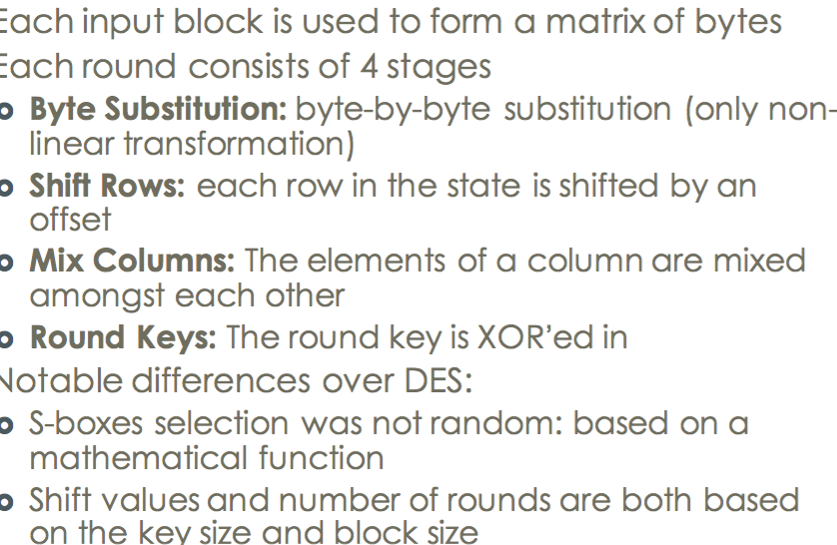

ECB Electronic Codebook

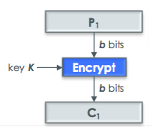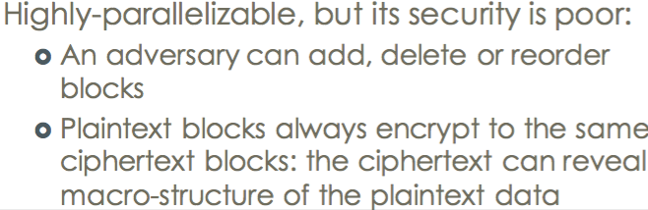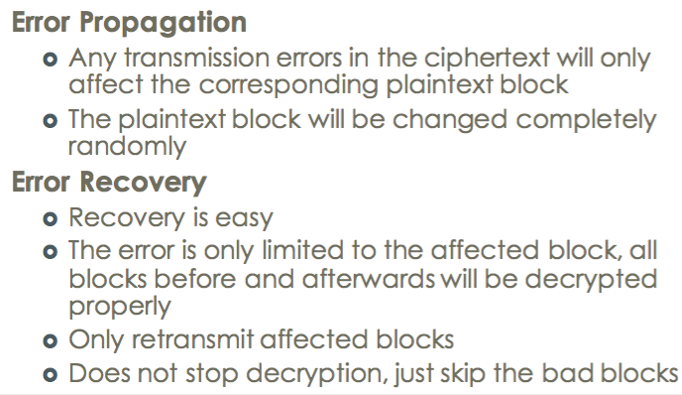

Cipher Block chaining (CBC)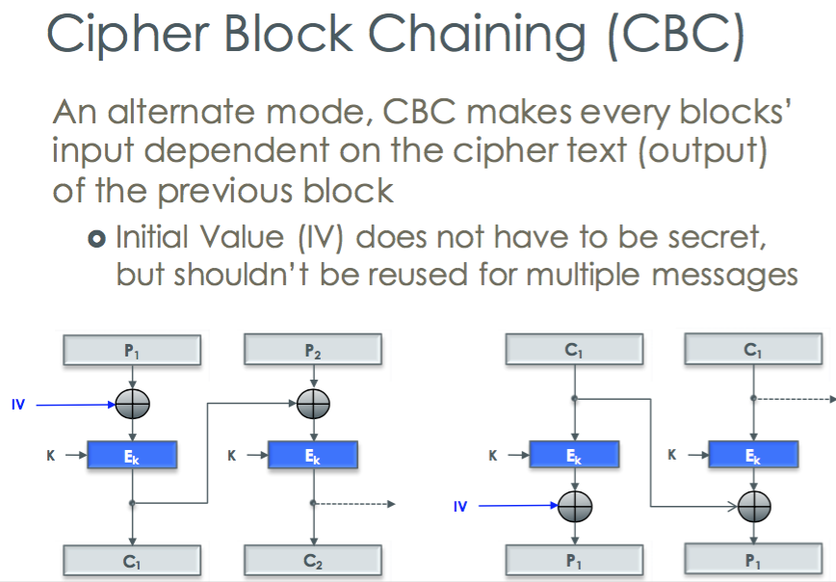

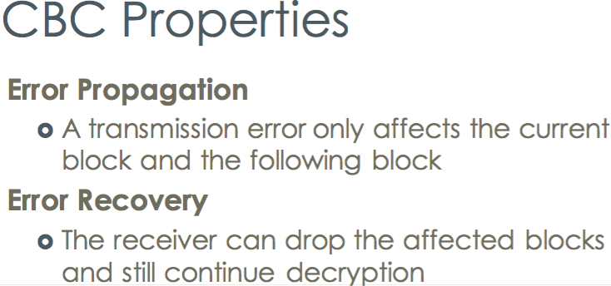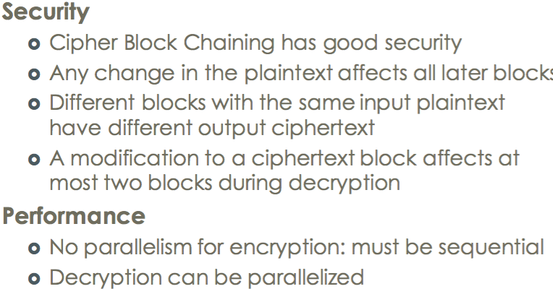

Cipher Feedback (CFB)

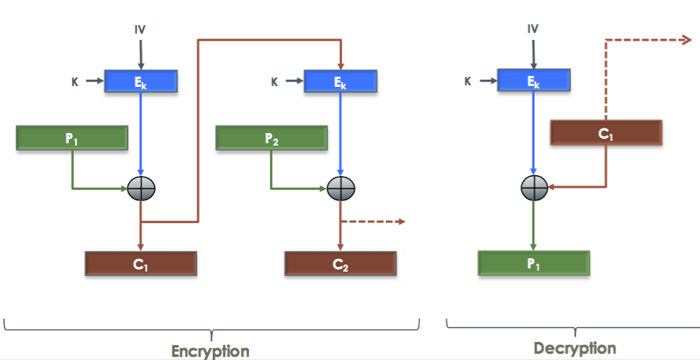

Output Feedback (OFB)

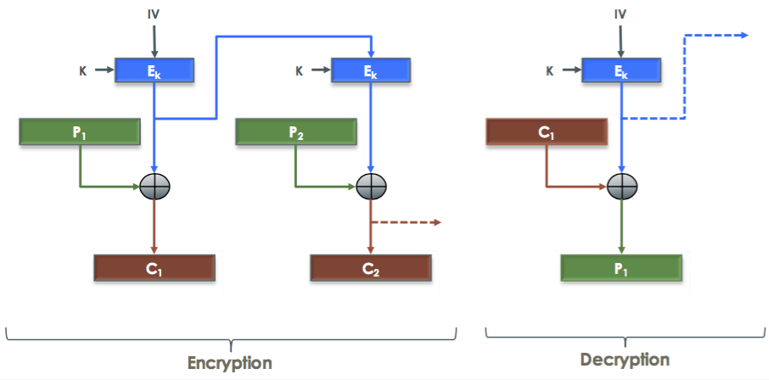

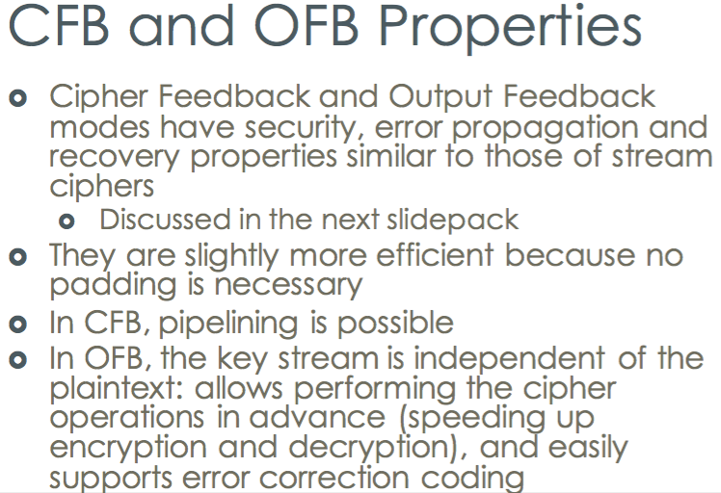

Stream cipher

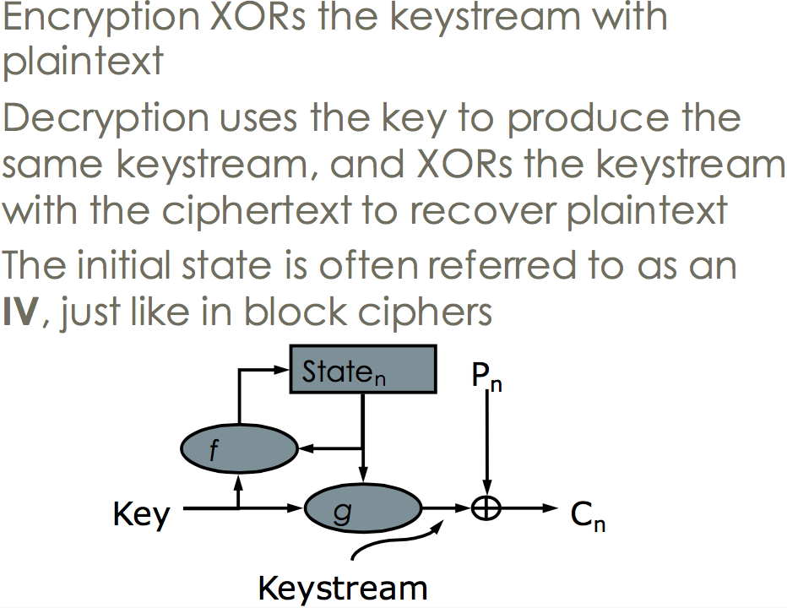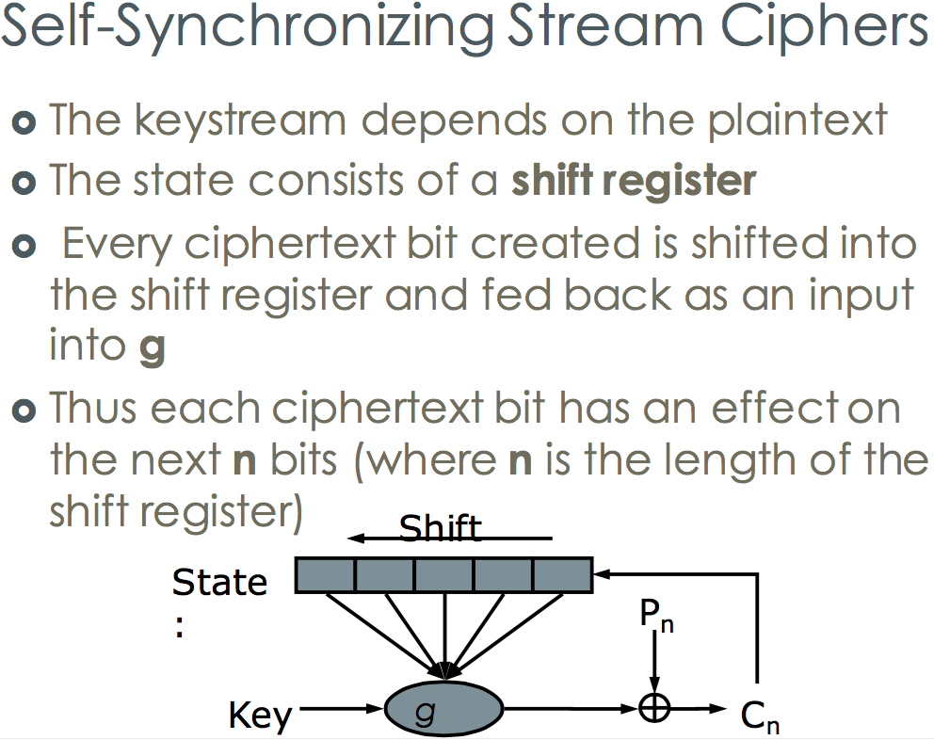

Security && Performance

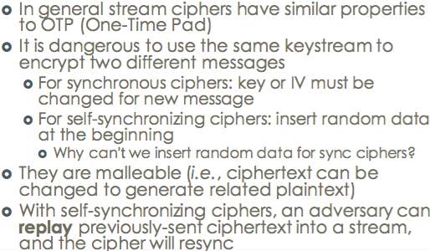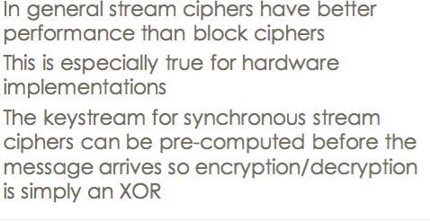

Error propagation && Error Recovery

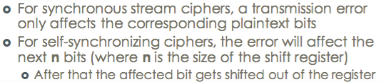

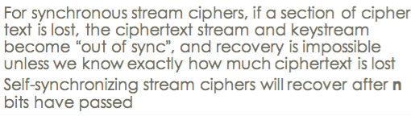

Needham-Schroeder Protocol

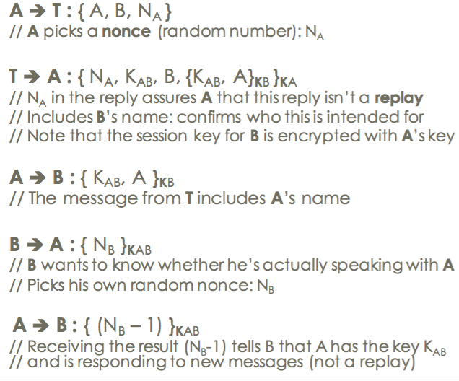

Diffie-Hellman Key Exchange

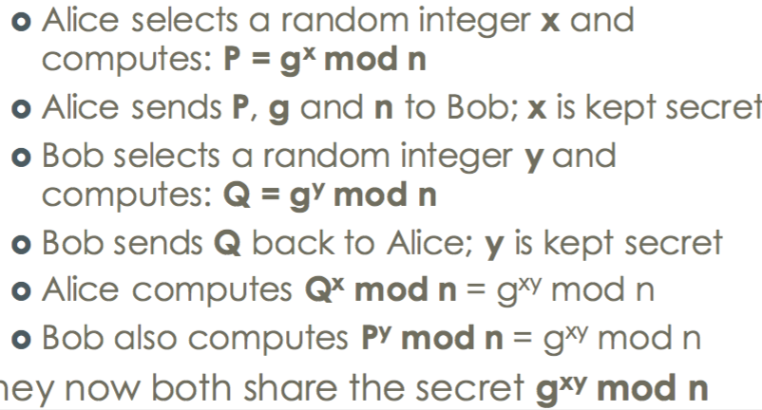

Public Key Encryption

the sender encrypts the message with the intended recipient’s public key, Only the recipient should have the private key, so only the recipient can decrypt the message

Public Key Authentication

For authentication, the message is encrypted with the sender’s private key (also called signing), Any recipient can decrypt using sender’s public key, Only sender could have encrypted the text we received, thus providing authentication and non-repudiation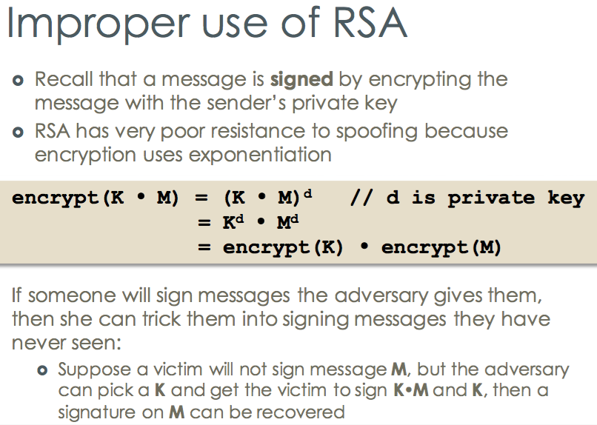

Public key Cryptography

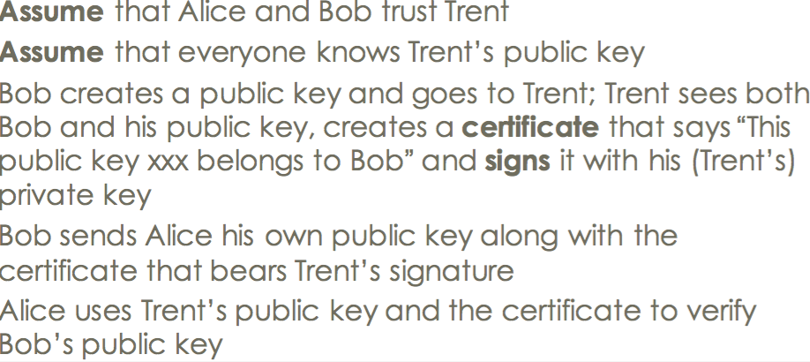

PGP: An Alternative to PKI

Public key exchange

Modification Detection Code -> Using MDC

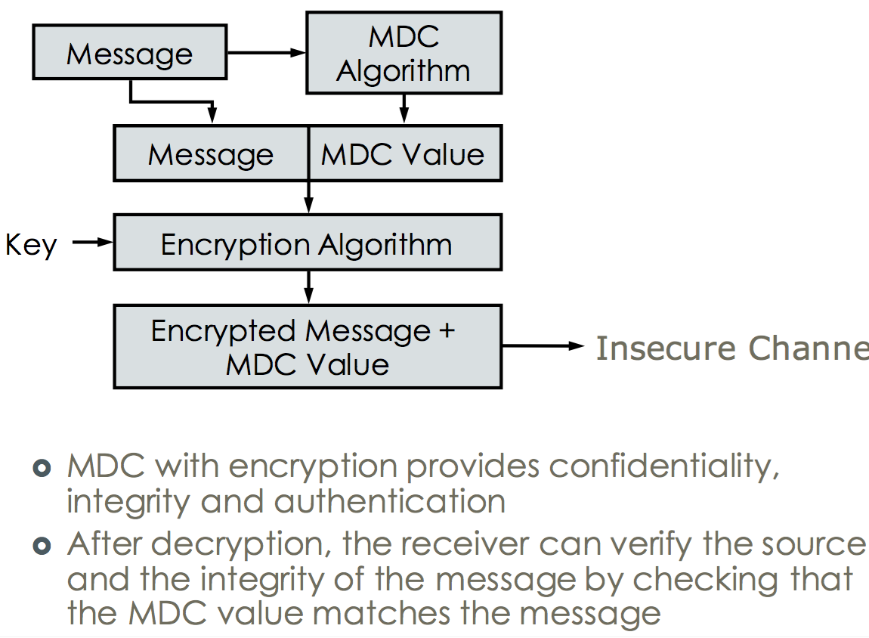

Message Authentication Code

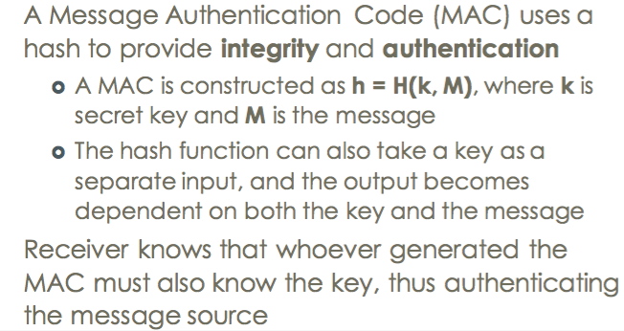

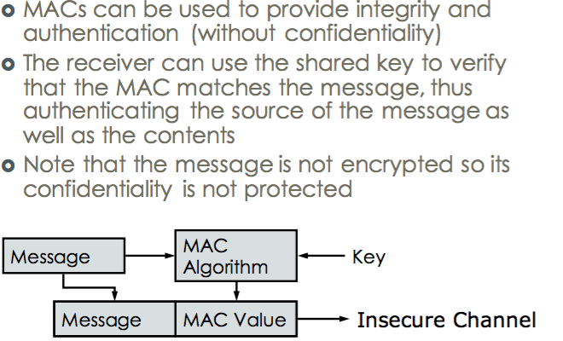

MAC using Symmetric Ciphers CBC-MAC

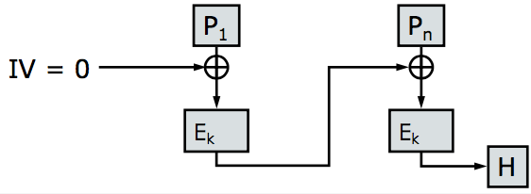

MAC using Hashes

HMAC = H[(K ⊕ opad) || H((K ⊕ ipad) || M)]

Replay attack

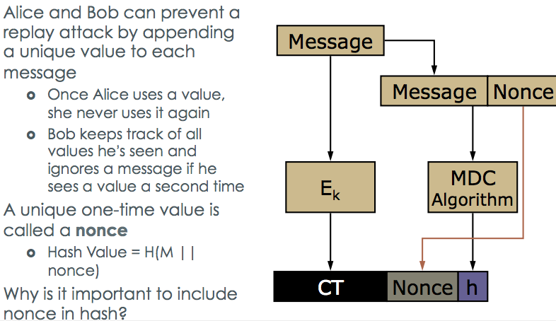

Reorder attack

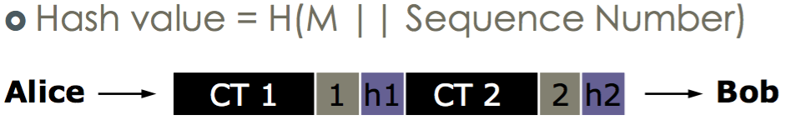

SSL

